**Mini Project: Business Intelligence & Big Data Analysis**

Name: Monika desai

Roll no-31

Class- Msc-cs(SEM-2)

Topic:

**Aim:** Implementation of NOSQL database using mongodb.

**Step1:** We need to download mongodb from <https://www.mongodb.com/try/download/community> website.

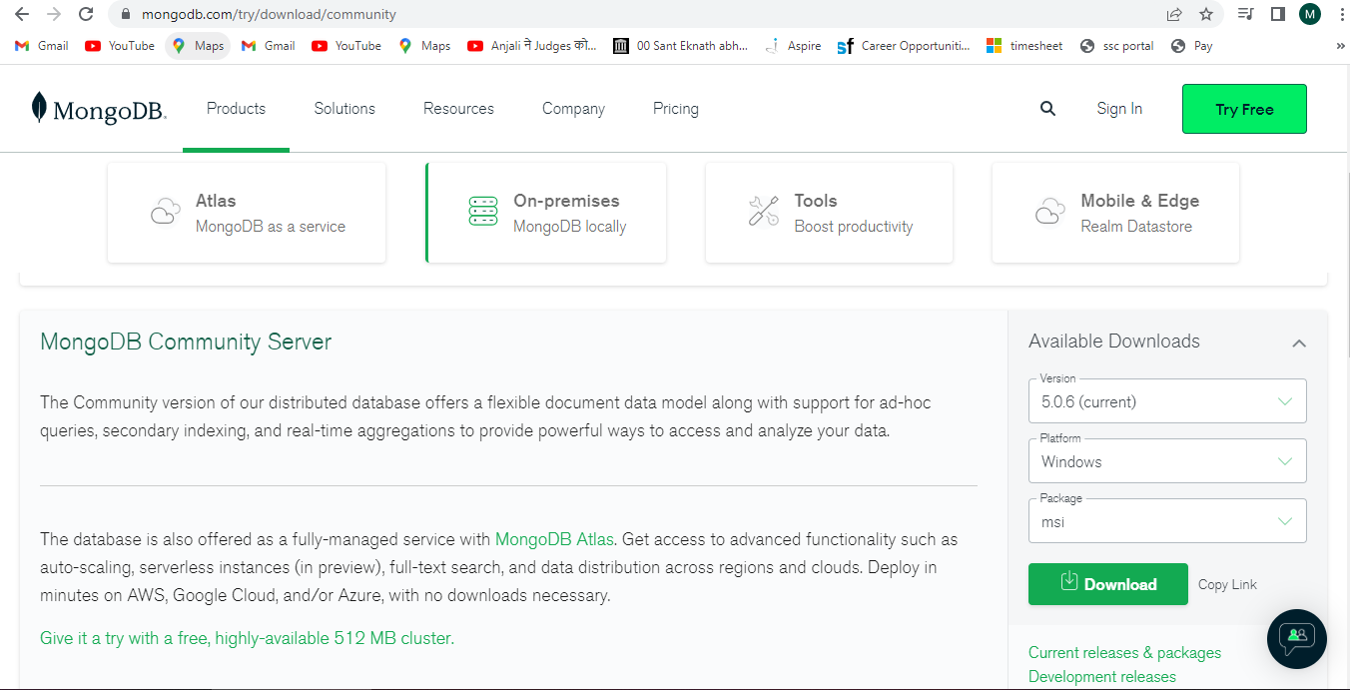

**Step2:** After successfully downloading mongodb we need to install it in our system.

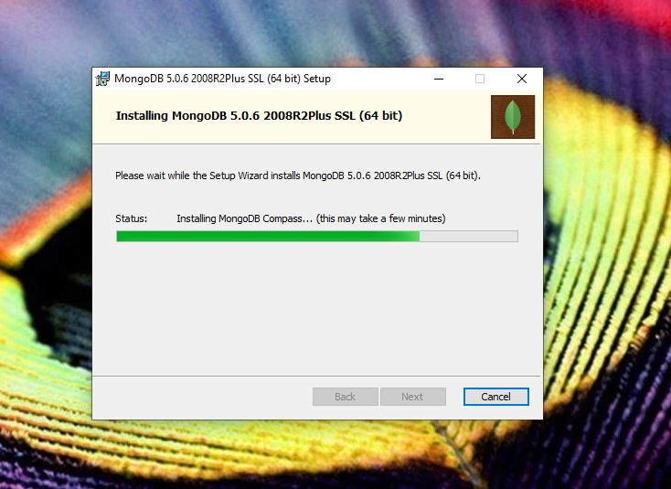

**Step3:** After successfully installation of the mongodb we need to set path variable of the bin file of mongodb in environment in system

.eg “C:\Program Files\MongoDB\Server\5.0\bin”

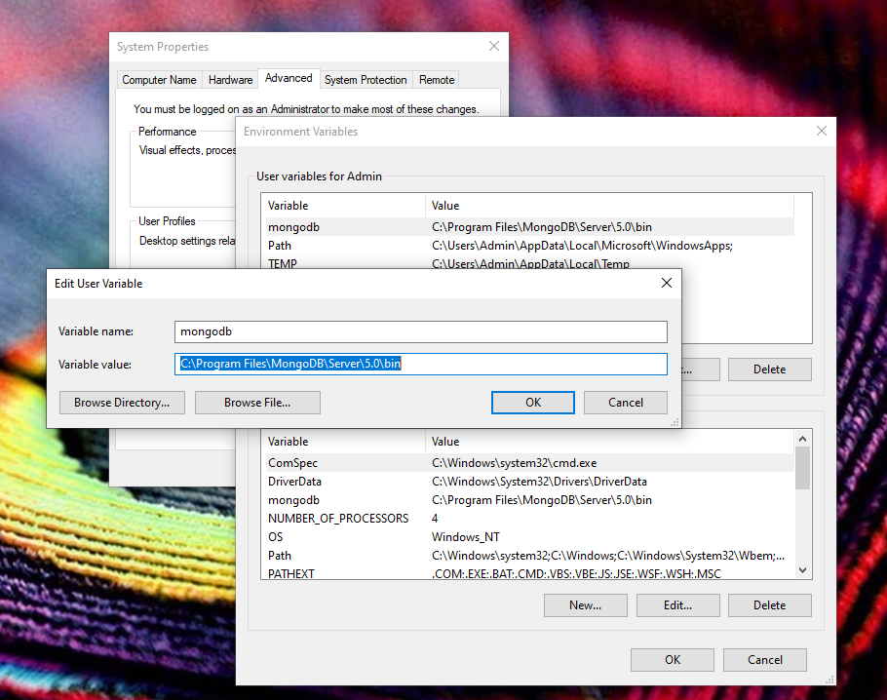

**Step4:** After setting path variable we can easily use mongo command in cmd and run mongodb shell.

Command : show dbs

show dbs command shows the database available in mongodb.

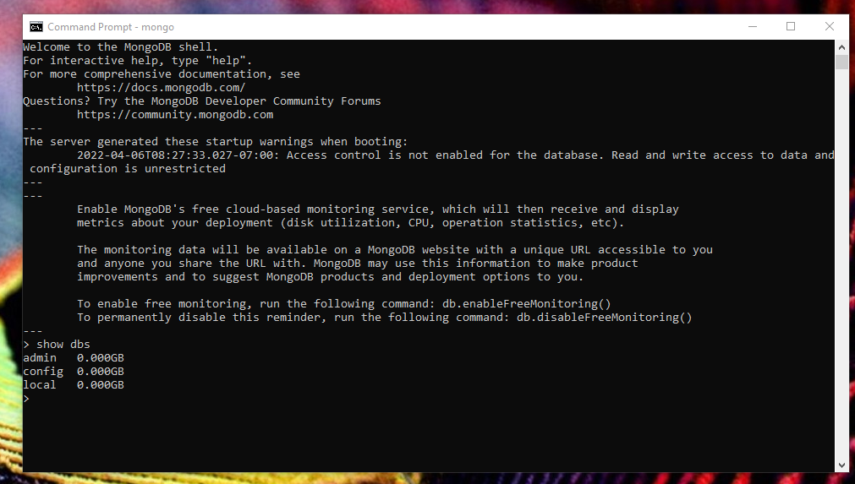

**Step5:** To create our own database in mongodb we need to write

“**use databasename”.**

Example:

Command : use studentdb

here, studentdb is the name of database

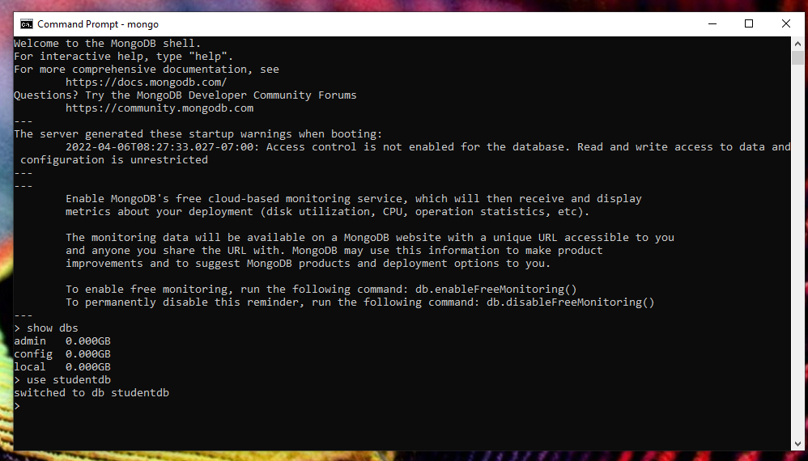

**Step6:** To create collection in database we need to write following command.

**Command** :

db.Student.insert({“StudentName” : “Monika”,“Address” : “Ghatkopar”, “Subject” : “Maths”, “Marks” : 40})

Here , Student is the table name

**Output**:

WriteResult({ "nInserted" : 1 })

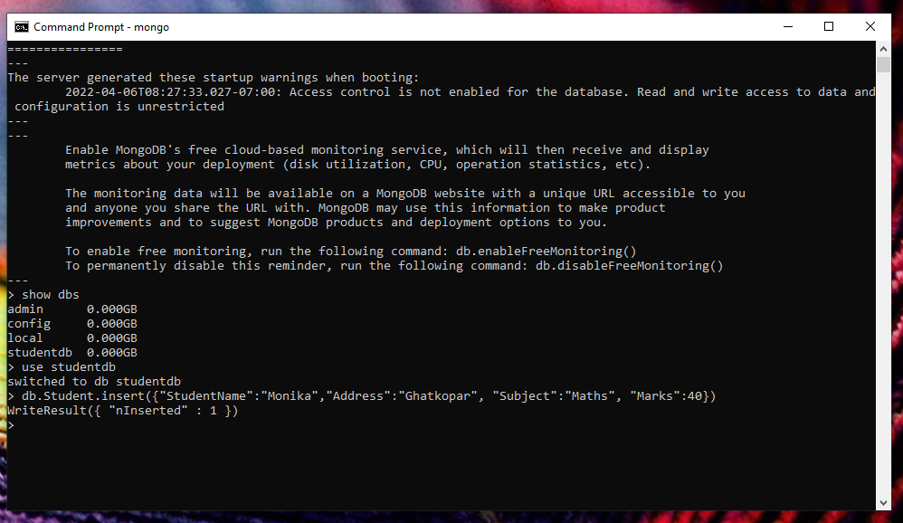

**Step7:** To view our collection we need command “**show collections**”

and to display record of collection we need to write command “**db.emp.find()**”

or “**db.emp.find().pretty()**”

